**Simple Path**

Given a connected tree with N vertices and N — 1 edges, you must answer M queries of the type:

• given three unique vertices A, B, and C, find if there exists a simple path that contains all three vertices.

Note: A simple path is a path in a tree that does not have repeating vertices.

**Input format**

• The first line contains a single integer T, which denotes the number of test cases.

• For each test case:

The first line contains N denoting the number of vertices in the tree.

The next N — I lines contain 2 space-separated integers, u and v,

indicating that there is an edge between vertices u & v.

The next line contains M denoting the number of queries.

The next M lines contain 3 unique space-separated integers, A, B, and C.

**Output format**

For each test case, answer all the M queries. For each query print Yes if there exists a simple path that contains all three vertices A, B, and C, otherwise print No. Print answer for each query in a new line.

**Constraints**

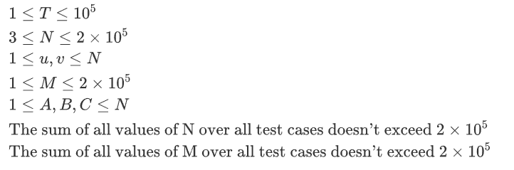

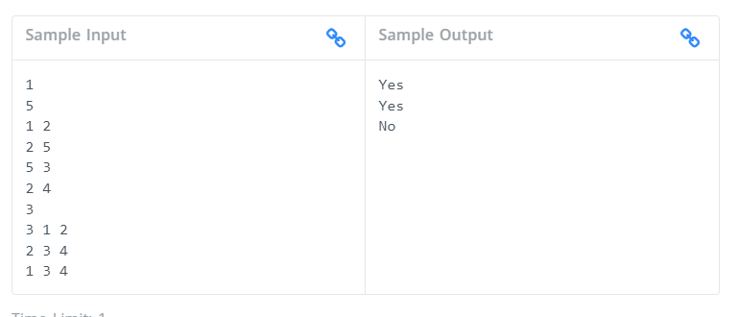

The first line denotes T

For test case 1:

We are given:

* N = 5
* M = 3

Now,

* For the first query, we have a simple path as 1 —+ 2 —+ 5 + 3, which
* contains all the three vertices 3, 1, and 2. Therefore the answer is Yes.
* For the Second query, we have a simple path as 4 —+ 2 —+ 5 + 3, which contains all the three vertices 2, 3, and 4. Therefore the answer is Yes.
* For the third query, there exists no simple path in the given tree which contains all the three vertices 1, 3, and 4. Therefore the answer is No.